FOR IMMEDIATE RELEASE
Press contact:
Camila Schaulsohn
212-358-6114 cschaulsohn@aiany.org
IMAGES AVAILABLE FOR PUBLICATION
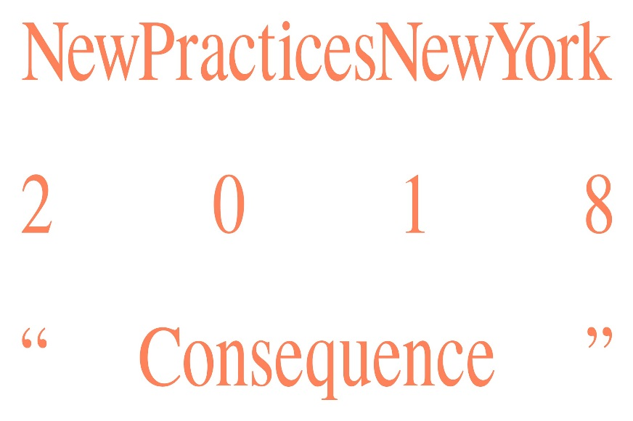
Announcing AIANY New Practices New York 2018 Winners
New Practices New York 2018 celebrates the innovative work of five NYC firms, to be featured in an exhibition at the Center for Architecture opening April 12, 2018.
NEW YORK, New York, February 3, 2018 – On Wednesday, January 24, the AIANY New Practices Committee welcomed the New Practices New York 2018 competition jury to the Center for Architecture, where they announced the competition’s five winners.
NEW PRACTICES NEW YORK COMPETITION WINNERS
Five innovative young firms were chosen as the New Practices New York 2018 competition winners:
Agency-Agency
MABU / Matt Burgermaster
N H D M / Nahyun Hwang + David Eugin Moon
Only If Architecture
P.R.O. – Peterson Rich Office
Representing more than 5,500 members, AIA New York is the oldest and largest chapter of an 80,000-member national organization. With its seventh biennial competition, AIANY’s New Practices Committee continues to serve as a platform for new and innovative models of architecture practice. Considering this year’s theme of “Consequence,” the jury recognized five firms that have chosen not to remain on the margins but rather actively and constructively engage their city, their society, and their context.
New Practices New York is a preeminent platform in New York City for recognizing and promoting young architecture and design firms. To qualify for this year’s competition, practices had to be founded since 2008 and be located within the five boroughs of New York City. The competition is open to multidisciplinary firms, widening the field of entrants to designers and young professionals currently in the process of becoming licensed architects.
This year’s distinguished panel of jurors was composed by Beatrice Galilee, Daniel Brodsky Associate Curator of Architecture and Design, The Metropolitan Museum of Art; Dan Howarth, US Editor, Dezeen; Jeffrey Inaba, Principal, Inaba Williams; Andrés Jaque, Founder, Office for Political Innovation; Hilary Sample, AIA, Principal and Co-founder, MOS Architects; and Rosalyne Shieh, AIA, Partner, Schaum/Shieh.
ABOUT THE WINNERS
Agency—Agency
Agency—Agency, founded by Tei Carpenter, seeks out an expanded agency for architecture’s role in society, engaging buildings but also systems beyond buildings. A notion of a world as collectively authored animates the firm’s work, which is grounded in current reality while constantly looking toward future horizons. Agency—Agency’s work is connected by a set of values that critically engage architecture’s role within contemporary environmental conditions, while endeavoring to produce a social agenda through generous and inclusive design. The practice explores the aesthetic limits of architecture and searches for new opportunities in ourstrange and unstable time.
MABU / Matt Burgermaster
MABU’s work focuses on material, spatial, and environmental leftovers. Rather than seeing existing things, old buildings, and forgotten places as ruins without a future, the firm considers them material and cultural resources imbued with transformative possibility. MABU activates the latent characteristics of such undervalued objects and engages with shared, systemic processes of making and re-making the built environment. The practice trades in the binary framework of old and new for alternative approaches to adaptive reuse that blend quotidian material realities with articulate spatial figures to more resourcefully and publicly re-imagine traditional notions of change, value, and waste.
N H D M / Nahyun Hwang + David Eugin Moon
N H D M is a collaborative practice for design and research in architecture and urbanism founded by Nahyun Hwang and David Eugin Moon. The firm strongly believes in the agency of architecture in articulating and addressing today’s complex social, political, cultural, and environmental issues. The realities of contemporary cities and their extended geographies serve not only as the subjects of investigation but as crucial inspirations and testing grounds for experimentation and transformation. Working across diverse scales, contexts, disciplinary frameworks, and methodologies, the practice aims to consistently produce rigorously articulated research, propositions, and material executions that critically engage the contemporary built environment in a unique and meaningful way.
Only If Architecture
Only If is a New York City-based design practice for architecture and urbanism founded in 2013. The firm is currently engaged in a range of projects, from the design of interiors to single- and multi-family housing, larger-scale urban planning, research, and speculation. When approaching any project, Only If seeks to focus on its fundamental questions and potentials. The ambition of this process is to create clarity and distill simplicity within often-complex circumstances and constraints. Rather than imposing additional regimes of complexity, Only If believes the role of the designer is to envision simple gestures and forms that impose structure, coherence, and identity.
P.R.O. – Peterson Rich Office
Founded by Miriam Peterson and Nathan Rich, P.R.O. advocates an expanded role for design. By operating at the margins of the discipline, the firm works opportunistically at the intersection between architecture, economics, and policy towards a more holistic understanding of sustainability within the social and economic context of our city. P.R.O. believes that architects can play the roles of imaginative mediator, consensus builder, and trusted ally to multiple stakeholders simultaneously. This privileged position, one often overlooked by traditional practice, is not easily played by those outside of the discipline. Each year, P.R.O.’s work leads to an ever-expanding field of collaborators and partners, which in turn has allowed the young office to engage in a wide range of topics and scales
EXHIBITION ON VIEW
As part of the award, firms will receive a stipend for an installation and exhibition at the Center for Architecture, which will open on April 12, 2018. The exhibition will be designed by Studio Lin. Members of the press are invited to the opening.
Special thanks to the supporters of New Practices New York 2018.
Media Partner
About AIA New York
AIA New York is the oldest and largest chapter of the American Institute of Architects with more than 5,500 architect, allied professional, student, and public members. AIANY is dedicated to three goals: design excellence, public outreach and professional development. www.aiany.org
About the Center for Architecture
The Center for Architecture is the premier cultural venue for architecture and the built environment in New York City, informed by the complexity of the City’s urban fabric and in dialogue with the global community. The Center shares a home with the AIA New York Chapter and has the unique advantage of drawing upon the ideas and experiences of practicing architects to produce thought-provoking exhibitions, informative public programs, and quality design education experiences for K-12 students. It also leads New York City’s annual month-long architecture and design festival, Archtober. The Center for Architecture’s aim is to further public knowledge about New York City architecture and architects, foster exchange and collaboration among members of the design, development, building, scholarly, and policy sectors, and inspire new ideas about the role of design in communities by presenting contemporary and practical issues in architecture and urbanism to a general audience. www.centerforarchitecture.org

